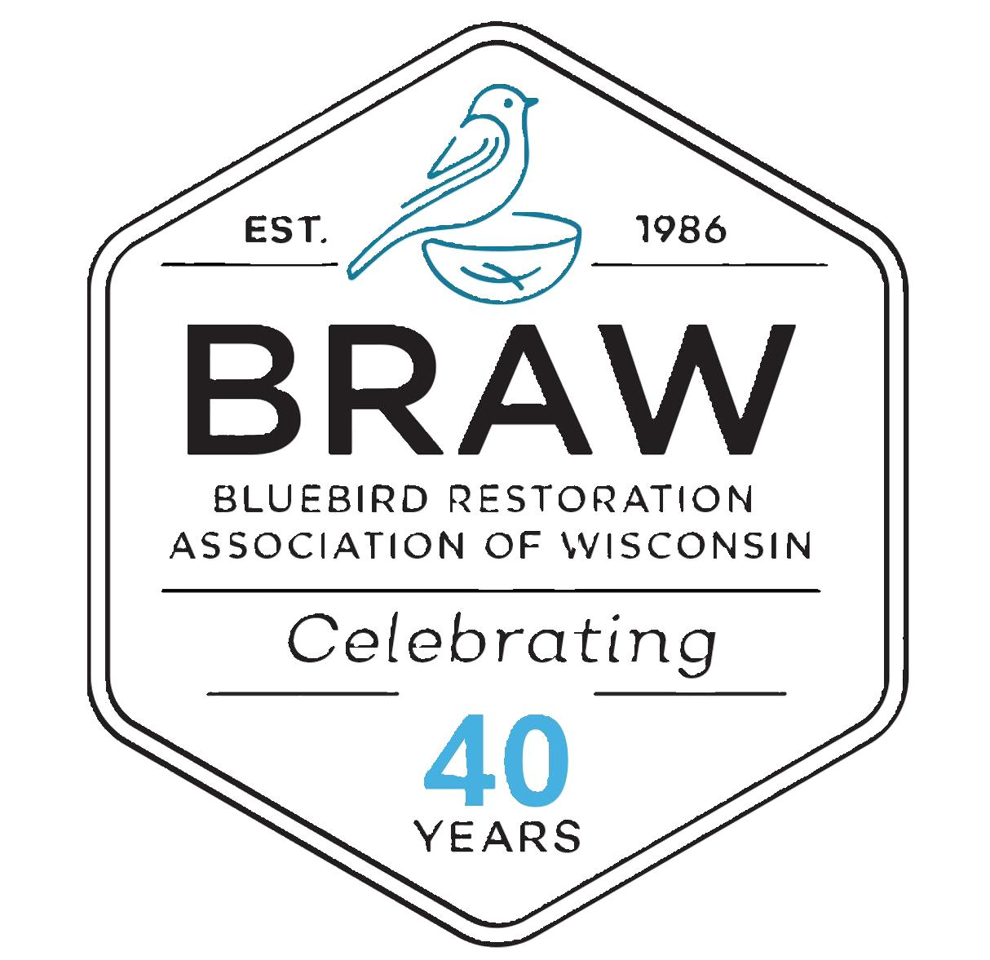

BRAW Board of Directors Meeting Agenda

June 7, 2025 – 9:15 a.m.
Waunakee Public Library
201 N. Madison, Waunakee

President Steve Sample Presiding

Call to Order
Roll Call
Changes to the Agenda
Approval of minutes from March 1, 2025

Officers’ Reports
a) President’s Report – Steve
b) Vice-President’s Report – Brad
c) Treasurer’s Report
Committee Reports
a) Membership – Val
b) Finance (Provided in Advance) – Joanie
b) Newsletter/Brochures – Pat
c) Research – Dave
d) Website – Andy
e) Technology – Mike
f) Historian – Gail
g) County Contacts – Gene Birr
h) Public Relations – Gene K.
I). Data Analysis and Evaluation – Steve F.

Old Business
a) Nest Box Replacement Program – (tabled from last meeting)
b) Speakers for the Convention -Pat
c) 2025 Strategic and Marketing Plans -Gene K.
d) Nesting Box labels – installation needs
e) Dan Shroeder approved by Board Email Vote
New Business
a) Policy and Specs. For Nesting Box Approval – Andy & Dave
b) Nesting Boxes given out - Gene
c) Fall Convention Update – Steve
d) Perry-Primrose Bird Conservation Area – Gene
e) 2025 Awards-Steve

Next BOD meeting tentative September 20, 2025
Adjournment

